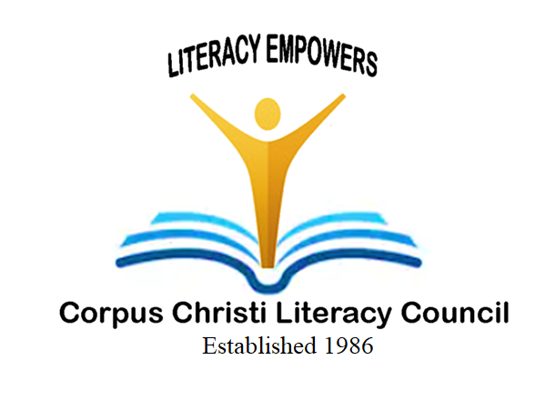 | Bowlero Corpus Christi  Saturday, July 12, 2025 from 1:00 pm - 3:00 pm  6116 Ayers Street, Corpus Christi, TX 78415  Pizza and soft drinks are included  Great Silent Auction Items!  Drawings for door prizes during tournament!  Register Now!! | 
2025 Team Registration Form
- Four Members per team
- Trophies awarded to: 1st, 2nd, 3rd, Place High Game – Men, Women & team
- Gutter Ball Prize for Lowest score Team & Individual
- Team Registration: $400. League and non-league bowlers are welcome

Sign me up for the Corpus Christi Literacy Council

“2025 Strike for Literacy Bowl”

If you have formed a team, please list team members below
Name/ CompanY | Phone:

Address:

Name: | E-mail: | PHONE:
aDDRESS: |  | mALE/fEMALE

Name: | E-mail: | PHONE:
aDDRESS: |  | mALE/fEMALE

Name: | E-mail: | PHONE:
aDDRESS: |  | mALE/fEMALE

Name: | E-mail: | PHONE:
aDDRESS: |  | mALE/fEMALE

Amount Enclosed $_______________

To pay by credit card please call: 361- 826-7086
Make check payable to: Corpus Christi Literacy Council
A 501 (C) 3 non-profit organization

Please complete the information and return this form to Corpus Christi Literacy Council
Address: 4044 Greenwood, Corpus Christi, Texas 78416

Phone: 361-826-7086 – Fax: 361: 826-7083 – E-mail: ccliteracy@ymail.com

