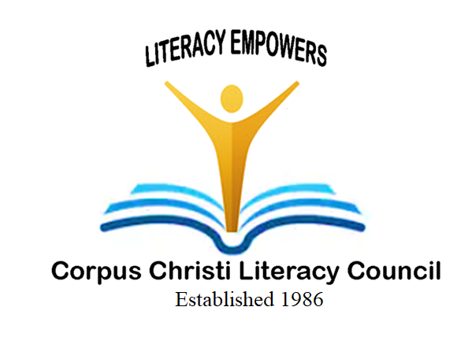 | “2025 Strike for Literacy Bowl”  Bowling to Strike Out Illiteracy  Bowlero Corpus Christi  Saturday, July 12, 2025 from 1:00 pm - 3:00 pm  6116 Ayers Street, Corpus Christi, TX 78415 | 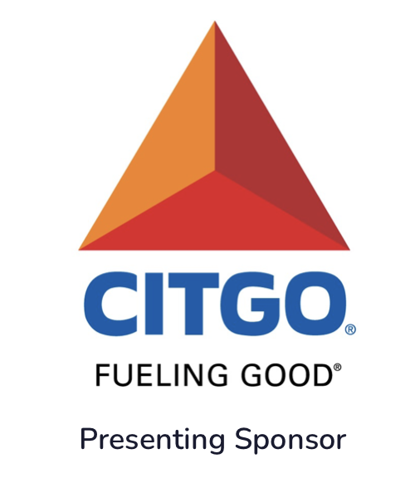
The Corpus Christi Literacy Council is a 501 (c) 3 non-profit agency that promotes literacy in our area. Our goal is to raise approximately $30,000 to be used toward teaching adult learners to improve their literacy and English language skills. You can provide that help in a simple and fun way!
Become a sponsor of the Bowling Tournament that will be held on Saturday, July 12, 2025. With your help, we are confident that we cannot only reach as many adults as possible who need our help, but also to ultimately end illiteracy in our great state of Texas.

2025 SPONSORSHIP LEVELS

Be a Presenting Sponsor (Perfect Game) *$8,000
- Top recognition for Strike for Literacy Bowl promotional materials
- Company name and logo displayed at the event, flyer and social media
- Brochures or promotional material in every player’s registration packet
- Total of six (6) bowling teams
- Company name mentioned in social media leading up to the event and listing on CCLC website
- Continuous recognition throughout the event by the Emcee

Be a Corporate Sponsor (Strike) *$5,000
- High recognition for Strike for Literacy Bowl promotional materials
- Company name and logo displayed at the event, flyer and social media
- Brochures or promotional material in every player’s registration packet
- Total of four (4) bowling teams
- Company name mentioned in social media leading up to the event and listing on CCLC website
- Continuous recognition throughout the event by the Emcee

Be a Benefactor Sponsor (Spare) * $3,000
- Medium recognition on all Strike for Literacy Bowl promotional materials
- Company name and logo displayed at the event
- Brochures or promotional material in every player’s registration packet
- Three (3) bowling teams
- Listing on CCLC website
- Continuous recognition throughout the event by the Emcee

Be a Supporting Sponsor (Split) * $1,500
- Recognition on all Strike for Literacy Bowl promotional materials
- Two (2) bowling teams
- Continuous recognition throughout the event by the Emcee

